**At-home toothbrushing behaviors of power/electric toothbrush users - a video observation study** ( 3900 words)

**Affiliations:** Rachel J. Kulchar*, E Jun Chang** , Sumukh Kak***, Isabel Roig Penso****

*Department of Chemistry, Princeton University, Frick Laboratory, Princeton, NJ 08544, USA

**Herman Ostrow School of Dentistry of USC, Los Angeles, CA, 90089, USA

***Department of Psychology, University of California, Los Angeles, CA, 90024, USA

****Department of Statistics, University of California, Los Angeles, CA, 90024, USA

**Keywords**: young adults, video observation, oral hygiene behavior, power toothbrush, dental recommendations

**Abbreviations**

ADA American Dental Association

SE Standard Error

CI Confidence Interval

# Abstract

In this paper, habitual brushing behaviors of young adults at home settings is discussed. We conducted a study consisting of 13 right-handed participants brushing their teeth using a power toothbrush for 10 brushing sessions each. Participants' faces were recorded during the brushing sessions using a phone camera and the data from the pressure sensor embedded in the brush is collected. Parameters of interest were brushing duration in total and on different dental surfaces and also the duration of brushing with excessive pressure in total and on different dental surfaces. We have studied these parameters on the study-population level to show the general behavioral trends as well as the participant and session level to study the inter-participant and intra-participant variabilities, respectively. The mean brushing duration for an average participant was 84.57 seconds, with more than 15 seconds inter-participant and intra-participant variability. It is shown that the buccal surfaces are generally brushed more than four and five times as long as the occlusal and lingual surfaces. Also, the occlusal surfaces are brushed with excessive pressure more than buccal and lingual surfaces. We have shown that the inter-participant and intra-participant variabilities are substantial in all the studied parameters and can make the individuals’ brushing behaviors different from and even opposite to the general behavioral trends in the study population. Hence, considering these variabilities is of substantial importance in giving brushing recommendations to individuals.

# Introduction

From both clinical and experimental studies, there is a strong relation between bacterial plaque and periodontal disease, with the most effective way of protecting against periodontal diseases being the manual removal of bacterial plaque from a tooth’s surface [1]. However, self-performed mechanical plaque removal via toothbrushing is often not sufficiently effective [2]. and proper brushing behavior is needed to maintain sustainable oral health. [3]

There is a small literature on brushing behavior. Different parameters were studied including duration of brushing in total in a brushing session and on different dental surfaces, brushing strokes types and frequency. Studies that considered brushing duration, have reported a wide range of times from 33 seconds [] to 156 seconds []. In comparison, for brushing different dental surfaces most studies have found that the buccal surfaces (outside of teeth surfaces) are brushed more than the lingual surfaces (inside of teeth surfaces) [][][]. There was not a consensus on the difference in duration of brushing on maxillary (upper jaw) and mandibular (lower jaw) as well as the different sides (right, left, and anterior (middle)). However these studies have explored the use of manual toothbrushes, a recent study [] have found similar brushing behavior in power toothbrush users.

The previous studies have mainly focused on the behavior of the whole study population and inter-participant (in between participants) and intra-participant (within a participant) variations in brushing behavior have not been discussed. These variations could possibly affect and even change the oral health recommendations that are given to each individual. Studying intra-participant brushing behavior requires to have more than one brushing session from each participant which has not been done in the previous studies. Additionally, the use of power toothbrushes have not been fully explored and however there is a LED light on the handle of these toothbrushes to warn the users when applying excessive pressure during brushing, it is not clear which dental surfaces are being brushed with excessive pressure for longer periods of time. Moreover, all these studies have been conducted in clinical settings and since the brushing behavior could possibly be different at home settings, there is a need for a study that is run at home settings.

In this paper, we study the habitual brushing behavior of power toothbrush users at home settings by collecting video recordings of the participants' faces while brushing. We also collected data from the pressure sensor embedded in the brush by designing a mobile app that could connect to the toothbrush via Bluetooth and use a cloud-based system to store the collected sensor data. Parameters of interest in our study were duration of brushing in total in a brushing session and on different dental surfaces and also duration of brushing with excessive pressure in total in a brushing session and on different dental surfaces. We not only explore the study population brushing behavior, but also study the participant-level and session-level brushing behavior of individuals to find out the inter-participant and intra-participant variability, respectively.

# Materials and Methods

## Study Design

For this study, we designed and deployed a mobile app which we named Oralytics. Oralytics was installed on the participants’ phones and connected to a power toothbrush via Bluetooth to collect data from the pressure sensor (generated with a sampling rate of 25Hz) embedded into the power toothbrush. However Oralytics is able to collect data from the motion sensors (accelerometer and gyroscope embedded into the toothbrush), we are not using that data in this study. The data was uploaded from Oralytics to our cloud-based system, CerebralCortex [], via WiFi connection for storage and visualization. We utilized the Oral-B® Genius X electric toothbrush as well as the Application Programming Interface (API) for the sensor data provided by the manufacturer.

We asked the participants to record their faces while brushing in order to have ground truth labels of the dental surfaces brushed during a brushing session. We provided each participant with a phone to use as a camera (with a frame rate of 30 frames per second), so that they could attach it to the mirror of their bathroom using a phone holder which we also provided.

Our overall experimental setup is diagrammed in Figure 1.

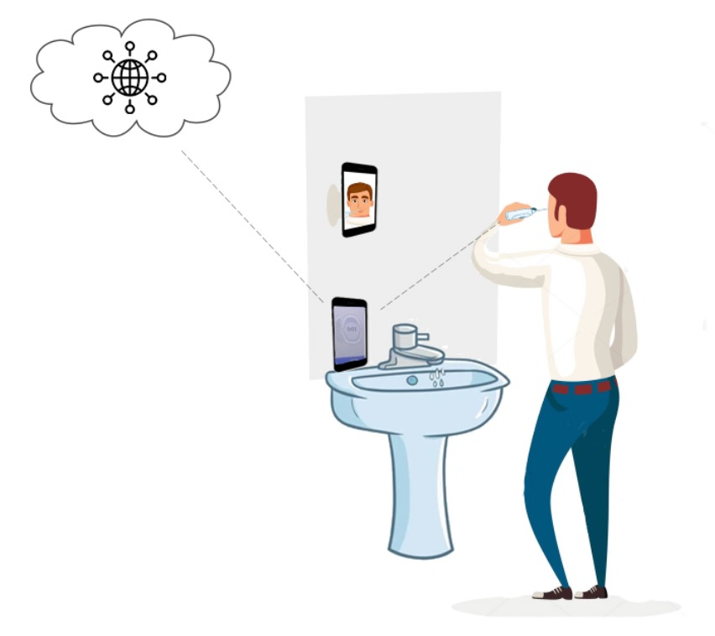

**Fig 1.** Assumed setup of participants during toothbrushing. The electric toothbrush sends the pressure sensor data to the Oralytics app on a phone/iPad via Bluetooth and the app will send the collected data to the cloud-based system, Cerebral Cortex, for storage and visualization. Also, concurrent video recording of participants' faces is done using phone cameras.

The Oralytics app is compatible with both Android and iOS devices. The app’s homescreen presents a dashboard of the user’s brushing history for the current day (Figure 2). Future versions of this app are under development to provide user feedback regarding their brushing behaviors.

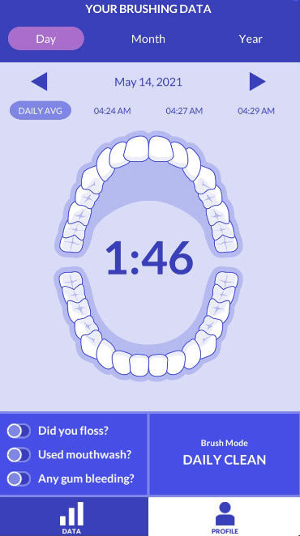

**Fig 2.** Oralytics app dashboard. Oralytics is the mobile app that was designed for our study to collect data from the pressure sensor embedded in the power toothbrush.

We initially enrolled 15 participants who consisted of undergraduate and graduate college students in our study to collect 50 brushing sessions from each of them over the course of three weeks. However the participants were incentivised by a free smart Oral-B® Genius X electric toothbrush, two participants left the study midway due to lack of sufficient incentive. Also, some brushing sessions had issues such as bluetooth connection failure, poor video recording, etc. We randomly selected 10 recorded brushing sessions that had no technical issues for each of the 12 participants (eight females and four males with ages ranging from 18 to 23 years (20.77 ± 1.59)) who completed the study, resulting in a total of 120 brushing sessions.

Inclusion criteria were (1) age ≥ 18, (2) provided written informed consent, (3) no professional training in dentistry, (4) full dentition with exception for orthodontic extractions. Exclusion criteria were (1) left-handedness (2) fixed orthodontic appliances, (3) physical or mental impairment that affects toothbrushing and dental hygiene, (4) removable dentures.

# Analyses

## Dental surfaces

We categorized the dental surfaces that were being brushed by dividing them into 16 surfaces (Figure 3), following the convention proposed in []. In this convention, dental surfaces are divided into maxillary (upper jaw) versus mandibular (lower jaw), right versus left versus anterior (middle) sides, and each of the teeth surfaces has buccal (outside), lingual (inside), and occlusal (flat) surfaces (expect for the anterior teeth surfaces that only have buccal and lingual sides).

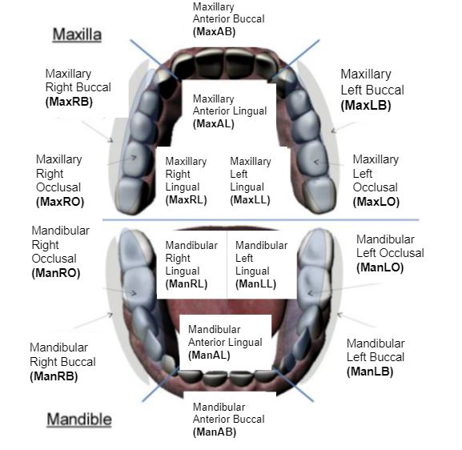

**Fig 3.** 16 dental surfaces (image retrieved from []) considered in this study.

## Labeling

We labeled the videos of the brushing sessions with a fine-grained resolution, in which every interval of brushing on a single dental surface that lasts at least 0.5 second received a label. This level of granularity is necessary for the delicate problem of monitoring toothbrushing behavior, in which users can move between different dental surfaces in a short span of time. We recorded the starting and end time (based on the video frames of the phone camera) of each period of brushing of a single dental surface within each brushing session.

## Statistical analysis

For statistical analysis, Matlab R2021a was employed. The dataset used as well as the code to generate the results are publicly available publicly at the corresponding author github repository [].

Th​​e pressure sensor streams data with a sampling rate of 25Hz and hence, it is count data. In order to have the brushing duration to be in the form of count data as well, we map the labels of the videos onto the motion sensors (accelerometer and gyroscope) data stream.

In order to report the parameters of interest in this study, it is important to represent the brushing duration using a model that can capture the inter-subject and intra-subject variabilities. Accordingly, we model the brushing duration using a Poisson regression model with a log link function and random effects by participant ID (both on intercept and on dental surfaces) and session ID (on intercept). Since there are regions that are skipped during brushing or have not been brushed with excessive pressure during a brushing session, we also represent the data using a zero-inflated Poisson regression model [] with fixed effects. However, the p-values obtained from both models suggest the same statistical claims using a significance-level (ɑ) of 5%. (see S1 appendix for mathematical details)

It is noteworthy to say that statistical tests such as the t-test are not suitable to apply on our dataset, since brushing duration is not normally distributed. Also, non-parametric tests such as the Winxcon test [], would not be satisfactory since the data samples are not independent due to having multiple brushing sessions from the same participant.

To demonstrate the data on different levels, we use boxplots. We draw sample points as outliers if they are not in the range of [q1 - w * (q3-q1) , q3 + w * (q3-q1)]; in which w is the Whisker value and q1 and q3 are the 25th and 75th percentiles of the sample data, respectively. We use a whisker value of ±2.7σ (σ is the standard deviation of the sample data) that corresponds to the coverage of 99.3% of the data, if the data is normally distributed.

# Results

We discuss each parameter of interest as follows:

1- Total duration of brushing in each brushing session: We calculated the effective brushing duration by excluding the times that were spent on moving the brush around the different dental surfaces or the pauses in brushing. Figure 4 shows the boxplot chart for the effective brushing duration for all the participants in our study. The mean brushing duration for an average participant (with no random effect) was 84.47 seconds. {91.67% of the participants (11 out of 12) brushed less than two minutes recommended brushing time in all their brushing sessions.} This sentence is confusing and seems incorrect

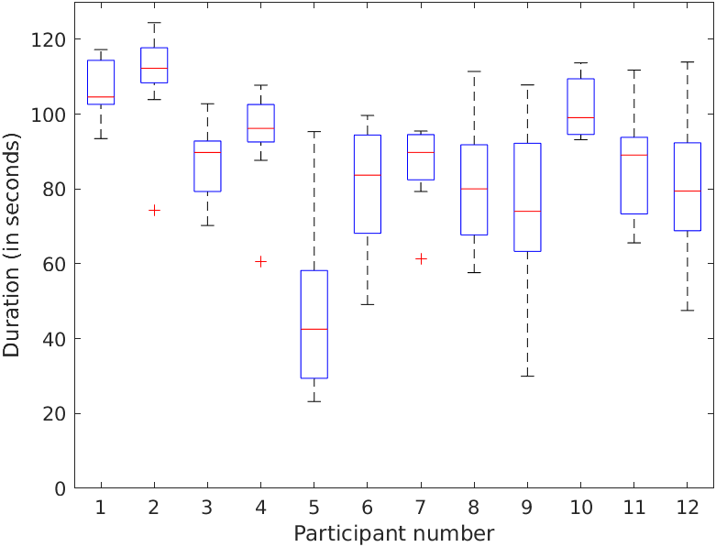

**Fig 4.** Brushing session durations of the participants in our study.

As it can be seen in Figure 4, there is a substantial intra-participant variability in brushing duration. Some participants (e.g. participants 2, 4, and 7) brush for almost the same duration of time as if they have an internal timer and some participants (e.g. participants 5, 9, and 12) brush for hugely different durations with over 70 seconds variation. Mean intra-participant variability estimated from the Poisson regression model is 15.27 seconds. Also, a substantial inter-participant variability can be observed. Some participants (e.g. participant 1 and 2) brush for almost two minutes, and some other participants (e.g. participant 5) brush for much less time as 40 seconds. Mean inter-participant variability in brushing duration estimated from the Poisson regression model is 16.64 seconds.

2- Duration of brushing on each dental surface: The boxplot of the duration of brushing of all of the 120 brushing sessions is shown in Figure 5. MaxAB, MaxLB, and MaxRB have been brushed for the longest time with a median of 10.68, 8.78, and 8.22 seconds in a brushing session, respectively; and MaxLL and MaxLO have been mostly skipped during brushing (median of zero second brushing time).

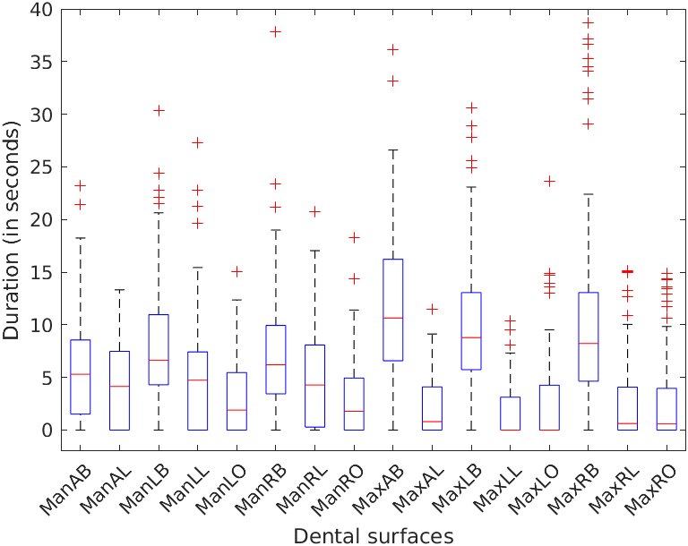

**Fig 5.** Population-level boxplot of brushing time on all the 16 dental surfaces

The brushing time categorized by different divisions of the dental surface is shown in Fig 6. As it can be seen, there is not much difference in brushing time spent on different sides (right, anterior, and left). Also, maxillary and mandibular regions are brushed around the same amount of time. This observation is confirmed by the Poisson regression model as there was no statistically significant difference in brushing time spent on other dental surfaces. However, brushing time on different teeth surfaces are different and buccal surfaces are brushed significantly more than the lingual and occlusal surfaces. Specifically, the Poisson regression model estimated that the buccal surfaces are brushed for 5.57 times as long as the lingual surfaces (95% CI 1.69, 18.33; p < 0.001) and for 4.68 times as long as the occlusal surfaces (95% CI 2.52, 8.71; p < 0.001), on average.

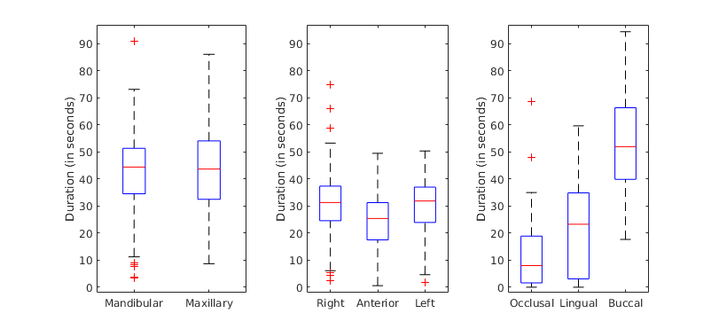

**Fig 6.** Population-level boxplot of brushing time on different divisions of dental surfaces

In addition to this trend on the study-population level, there are substantial inter-subject variabilities on participant level as confirmed by the Poisson regression model. Some participants (e.g. participant 4) brush the dental surfaces on the left side of their mouth, substantially more than the right side and some participants (e.g. participant 7) do the opposite (Fig 7). Some participants (e.g. participant 11), brush their lingual surfaces very little, and some (e.g. participant 9) brush their occlusal surfaces very little (Fig 8). Also, similar variabilities can be observed for maxillary and mandibular regions (Fig 9).

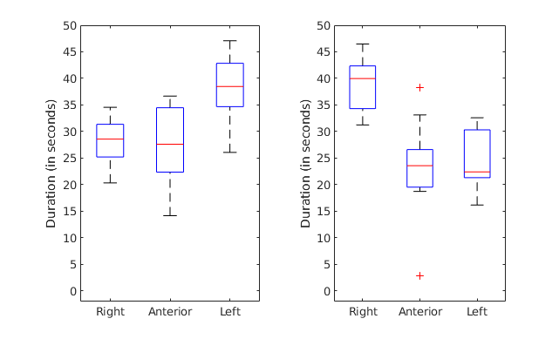

**Fig 7.** Inter-subject variability of brushing duration on right, anterior and left surfaces. Participant 4 (on the left) brushes their left surfaces more than their anterior left surfaces and participant 7 (on the right) brushes their right surfaces more than the rest.

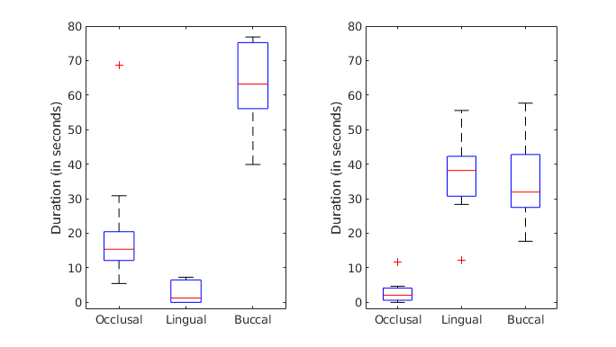

**Fig 8.** Inter-subject variability of brushing duration on occlusal, lingual and buccal surfaces. Participant 11 (on the left) brushes their lingual surfaces much less than their buccal and occlusal surfaces and participant 9 (on the right) brushes their occlusal surfaces very little.

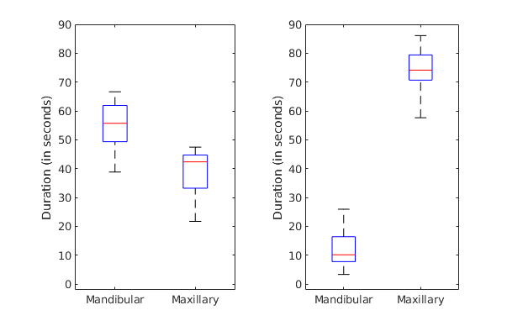

**Fig 9.** Inter-subject variability of brushing duration on mandibular and maxillary surfaces. Participant 4 (on the left) brushes their mandibular surfaces substantially more than their maxillary surfaces and participant 7 (on the right) brushes their maxillary surfaces more.

Also, a substantial intra-participant variability is estimated by the Poisson regression model with a 13% difference in brushing time spent on different dental surfaces on average. For instance, participant 2 brushes their lingual teeth for a varying amount of time from missing to brush those surfaces completely to brushing them for 60 seconds in a brushing session (Fig 10).

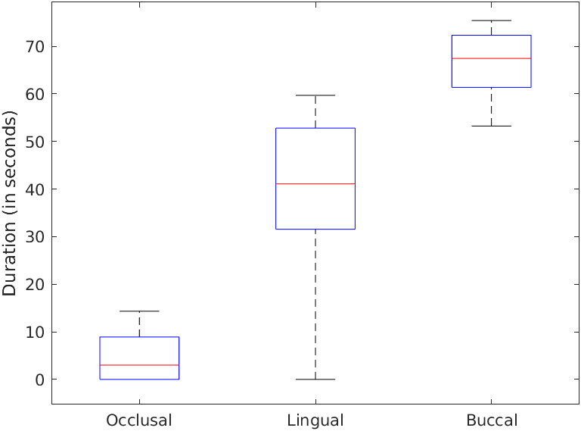

**Fig 10.** Intra-subject variability of brushing durations. Participant 2 brushes their lingual sides for a hugely variable duration.

3- Total duration of brushing with excessive pressure in each brushing session: Pressure during brushing is mostly normal (Fig 11) and only 0.5% of the time brushing is performed with excessive pressure. Some participants (e.g. participant 3 and 4) do not have any excessive pressure on any dental surfaces. 16.67% of the participants (i.e. participants 1 and 11) brush with a median of more than one second of brushing with excessive pressure during about two minutes of total brushing.

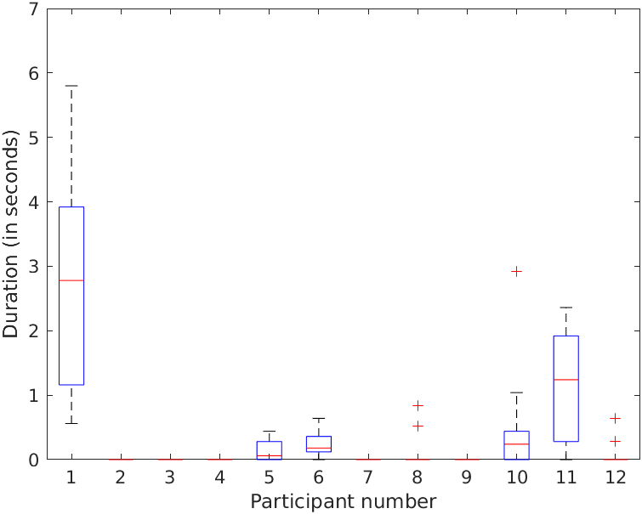

4- Duration of brushing with excessive pressure on each dental surface: The boxplot of this parameter of interest is shown in Fig 11. There exists a lot of outliers indicating sporadic periods of excessive pressure upto about 2.5 seconds during brushing. ManLO and ManRO are brushed with the most incidences of excessive pressure compared to all the other surfaces.

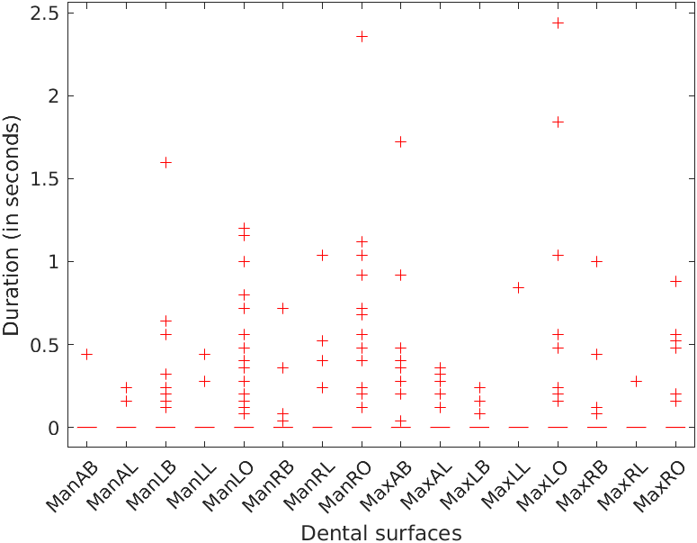

**Fig 11.** Population-level boxplot of brushing duration with excessive pressure on all the 16 dental surfaces

The brushing time with excessive pressure on different divisions of dental surfaces is shown in Fig 12. There is not much difference in the duration of brushing with excessive pressure can be observed in either of these plots. However, from the Poisson regression model, occlusal surfaces are brushed with excessive pressure 3.74 and 3.67 times as long as the buccal and lingual surfaces. There was no statistically significant difference between the other divisions of dental surfaces.

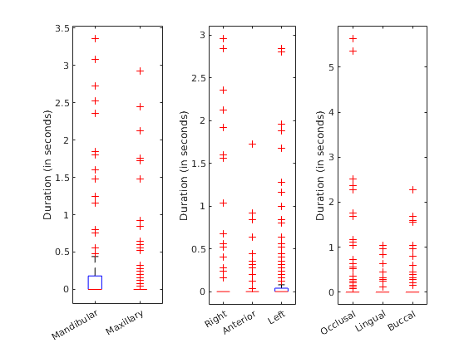

**Fig 12.** Population-level boxplot of brushing time with excessive pressure on different divisions of dental surfaces

Inter-participant variability for brushing duration with excessive pressure is substantial as well. Some participants need to be instructed to brush certain surfaces with less pressure. For instance, as it can be seen in Fig 13, participant 6 needs to brush the ManLO region with less pressure and participant 11 needs to use less pressure on the mandibular surfaces.

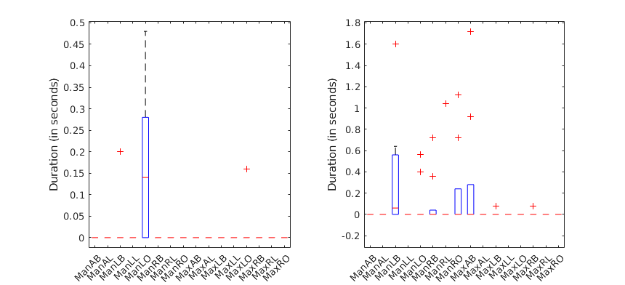

**Fig 13.** Inter-subject variability of brushing duration with excessive pressure on dental surfaces. Participant 6 (on the left) mostly brushes ManLO with excessive pressure and participant 11 (on the right) mostly brushes their mandibular surfaces with excessive pressure.

# Discussion

An accurate observational study should be conducted in a way that does not get influenced by other factors rather than the parameter of interest. Most of the studies on toothbrushing behavior have been conducted in a clinical setting [][][][] which limits its applicability to brushing at home as the most common way of practicing toothbrushing. In this study, we used a cloud-based system to monitor brushing behavior at home settings.

During a brushing session there are times that the brush is moving between different dental surfaces or the brush user is taking a pause; hence we reported the effective brushing time that was solely spent on brushing the dental surfaces. It is not clear if the two minutes recommended brushing time considers the effective brushing time or not, but from our analysis, we found that an average person's effective and non-effective brushing time is 84.47 and 122.92 seconds, respectively. Considering this difference, which is about 40 seconds in our study, can be important in analysing brushing time.

Brushing with excessive pressure can cause gingival abrasion and bleeding. Janusz et al. [], found that 46.3% of the participants activated the pressure sensor of the toothbrush for at least four seconds of the two minute brushing interval. However, we found that only 16.67% of our participants brush with excessive pressure with a median of more than one second during a brushing session. Hence, we did not find excessive pressure during toothbrushing to be prevalent.

Studying trends of brushing behavior prevalent in the study-population can be useful in giving general brushing recommendations. By modeling the duration of brushing on different dental surfaces, we found that our study population tends to brush their buccal surfaces more than four times as long as their occlusal and lingual surfaces. Interestingly, similar observations have been made in the previous studies [][][][]. We did not find any statistically significant difference between brushing occlusal and lingual surfaces, however some studies found that lingual surfaces are brushed significantly less than both occlusal and buccal surfaces [][]. Also, however we did not find any statistically significant difference between the different left, anterior, and right sides and also between the mandibular and maxillary sides, some studies found that the mandibular surfaces are brushed more than maxillary surfaces [][]. Considering the pressure applied during brushing, we have found that the occlusal surfaces are brushed with excessive pressure longer than the buccal surfaces. However, we did not find any other significant difference between other divisions of dental surfaces. Previous studies did not compare the different dental surfaces in terms of the pressure that was applied during toothbrushing.

Given that there is a substantial inter-individual and intra-individual variability in brushing behavior, brushing recommendations should be individually tailored. In particular, we found that on effective brushing duration there can be over 70 seconds difference between different individuals. Also, some individuals brush for almost the same duration which shows that toothbrushing has become a habit with a specific duration for these individuals. For other individuals, brushing duration can vary upto 70 seconds. In terms of brushing on specific brushing surfaces, individuals’ behavior can be different and even opposite the general population behavior. Some individuals spend extra time brushing their left or right side unproportionally and some neglect to brush their occlusal or their lingual surfaces. Also, excessive pressure has a great inter-individual variability. Some individuals need to apply less pressure on one specific surface and some need to apply less pressure on a particular side (e.g. mandibular surfaces). Solely considering the general brushing behavior trends and ignoring individual differences, could result in false brushing recommendations.

There are some limitations in our study that should be considered. We only recruited right-handed young adults who used power toothbrushes and hence the results can not be generalized to the left-handed population, manual brush users or other age groups. Also, the study happened over several days (53.3 ± 34.7 days) since there were problems with connections of the brush sensors to Oralytics app and the brushing behavior of individuals could have changed during the course of the study. In addition, since we only had 12 participants in this study, it is worth validating our results with more participants to increase generalizability.

By collecting multiple brushing sessions of individuals in this study, we analysed the inter-individual and intra-individual variability in brushing behavior. Since people seem to follow a habitual brushing pattern, merely instructing people to follow standard brushing techniques is simply not enough. Instead, it is essential to note individualized brushing flaws and parlay those inadequacies to each tooth brusher. The findings of this study could be used to develop systems that can give individually tailored brushing recommendations.

**Acknowledgement**

This research was made possible by…

**References**

[Ainamo, J. 1971. “The Effect of Habitual Toothcleansing on the Occurrence of Periodontal Disease and Dental Caries.” *Suomen Hammaslaakariseuran Toimituksia = Finska Tandlakarsallskapets Forhandlingar* 67 (1): 63–70.](https://www.zotero.org/google-docs/?290hWS)

[Andlaw, R. J. 1978. “Oral Hygiene and Dental Caries--a Review.” *International Dental Journal* 28 (1): 1–6.](https://www.zotero.org/google-docs/?290hWS)

[Bellini, Hamilton Taddei, Pål Arneberg, and Frithjof R. Von Der Fehr. 1981. “Oral Hygiene and Caries: A Review.” *Acta Odontologica Scandinavica* 39 (5): 257–65. https://doi.org/10.3109/00016358109162287.](https://www.zotero.org/google-docs/?290hWS)

[Berenie, James, Louis W. Ripa, and Gary Leske. 1973. “THE RELATIONSHIP OF FREQUENCY OF TOOTHBRUSHING, ORAL HYGIENE, GINGIVAL HEALTH, AND CARIES-EXPERIENCE IN SCHOOL CHILDREN.” *Journal of Public Health Dentistry* 33 (3): 160–71. https://doi.org/10.1111/j.1752-7325.1973.tb00656.x.](https://www.zotero.org/google-docs/?290hWS)

[Çakur, Binali, Mehmet Yildiz, Şenol Dane, and Yahya Orçun Zorba. 2011. “The Effect of Right or Left Handedness on Caries Experience and Oral Hygiene.” *Journal of Neurosciences in Rural Practice* 02 (01): 040–042. https://doi.org/10.4103/0976-3147.80093.](https://www.zotero.org/google-docs/?290hWS)

[“Caries Incidence and Lesion Progression from Adolescence to Young Adulthood: A Prospective 15-Year Cohort Study in Sweden.” 2004. *British Dental Journal* 197 (1): 28–28. https://doi.org/10.1038/sj.bdj.4811413.](https://www.zotero.org/google-docs/?290hWS)

[Costa, Fernando Oliveira, Luís Otávio Miranda Cota, Eugênio José Pereira Lages, Gislene Clemente Vilela Câmara, Sheila Cavalca Cortelli, José Roberto Cortelli, José Eustáquio Costa, and Telma Campos Medeiros Lorentz. 2011. “Oral Impact on Daily Performance, Personality Traits, and Compliance in Periodontal Maintenance Therapy.” *Journal of Periodontology* 82 (8): 1146–54. https://doi.org/10.1902/jop.2011.100515.](https://www.zotero.org/google-docs/?290hWS)

[Creeth, Jonathan E., Andrew Gallagher, Joseph Sowinski, James Bowman, Kathy Barrett, Shirley Lowe, Kartik Patel, and Mary Lynn Bosma. 2009. “The Effect of Brushing Time and Dentifrice on Dental Plaque Removal in Vivo.” *Journal of Dental Hygiene: JDH* 83 (3): 111–16.](https://www.zotero.org/google-docs/?290hWS)

[Dale, John W. 1969. “Toothbrushing Frequency and Its Relationship to Dental Caries and Periodontal Disease.” *Australian Dental Journal* 14 (2): 120–23. https://doi.org/10.1111/j.1834-7819.1969.tb04290.x.](https://www.zotero.org/google-docs/?290hWS)

[Deinzer, Renate, Stefanie Ebel, Helen Blättermann, Ulrike Weik, and Jutta Margraf-Stiksrud. 2018. “Toothbrushing: To the Best of One’s Abilities Is Possibly Not Good Enough.” *BMC Oral Health* 18 (1): 167. https://doi.org/10.1186/s12903-018-0633-0.](https://www.zotero.org/google-docs/?290hWS)

[Ebel, S., H. Blättermann, U. Weik, J. Margraf-Stiksrud, and R. Deinzer. 2019. “High Plaque Levels after Thorough Toothbrushing: What Impedes Efficacy?” *JDR Clinical & Translational Research* 4 (2): 135–42. https://doi.org/10.1177/2380084418813310.](https://www.zotero.org/google-docs/?290hWS)

[Ganss, C., R. Duran, T. Winterfeld, and N. Schlueter. 2018. “Tooth Brushing Motion Patterns with Manual and Powered Toothbrushes—a Randomised Video Observation Study.” *Clinical Oral Investigations* 22 (2): 715–20. https://doi.org/10.1007/s00784-017-2146-7.](https://www.zotero.org/google-docs/?290hWS)

[Janusz, Karen, Bruce Nelson, Robert D. Bartizek, Patricia A. Walters, and Aaron R. Biesbrock. 2008. “Impact of a Novel Power Toothbrush with SmartGuide Technology on Brushing Pressure and Thoroughness.” *The Journal of Contemporary Dental Practice* 9 (7): 1–8.](https://www.zotero.org/google-docs/?290hWS)

[Lee, Hee-Kyung, Sang-Hee Choi, Kyu Chang Won, Anwar T. Merchant, Keun-Bae Song, Seong-Hwa Jeong, Sung-Kook Lee, and Youn-Hee Choi. 2009. “The Effect of Intensive Oral Hygiene Care on Gingivitis and Periodontal Destruction in Type 2 Diabetic Patients.” *Yonsei Medical Journal* 50 (4): 529. https://doi.org/10.3349/ymj.2009.50.4.529.](https://www.zotero.org/google-docs/?290hWS)

[Litonjua, Luis A., Sebastiano Andreana, Peter J. Bush, Thomas S. Tobias, and Robert E. Cohen. 2004. “Wedged Cervical Lesions Produced by Toothbrushing.” *American Journal of Dentistry* 17 (4): 237–40.](https://www.zotero.org/google-docs/?290hWS)

[Löe, Harald. 2000. “Oral Hygiene in the Prevention of Caries and Periodontal Disease.” *International Dental Journal* 50 (3): 129–39. https://doi.org/10.1111/j.1875-595X.2000.tb00553.x.](https://www.zotero.org/google-docs/?290hWS)

[Macgregor, I. D. M., and A. J. Rugg-Gunn. 1979. “Survey of Toothbrushing Duration in 85 Uninstructed English Schoolchildren.” *Community Dentistry and Oral Epidemiology* 7 (5): 297–98. https://doi.org/10.1111/j.1600-0528.1979.tb01235.x.](https://www.zotero.org/google-docs/?290hWS)

[Mathur, Vijay Prakash, and Jatinder Kaur Dhillon. 2018. “Dental Caries: A Disease Which Needs Attention.” *The Indian Journal of Pediatrics* 85 (3): 202–6. https://doi.org/10.1007/s12098-017-2381-6.](https://www.zotero.org/google-docs/?290hWS)

[Menghini, G. D., M. Steiner, T. M. Marthaler, and R. M. Weber. 2001. “[Decline of caries prevalence in Swiss military recruits between 1970 and 1996].” *Schweizer Monatsschrift Fur Zahnmedizin = Revue Mensuelle Suisse D’odonto-Stomatologie = Rivista Mensile Svizzera Di Odontologia E Stomatologia* 111 (4): 410–16.](https://www.zotero.org/google-docs/?290hWS)

[Pita-Fernández, Salvador, Antonio Pombo-Sánchez, Juan Suárez-Quintanilla, Silvia Novio-Mallón, Berta Rivas-Mundiña, and Sonia Pértega-Díaz. 2010. “Relevancia clínica del cepillado dental y su relación con la caries.” *Atención Primaria* 42 (7): 372–79. https://doi.org/10.1016/j.aprim.2009.10.014.](https://www.zotero.org/google-docs/?290hWS)

[Rugg-Gunn, A. J., and I. D. M. Macgregor. 1978. “A Survey of Toothbrushing Behaviour in Children and Young Adults.” *Journal of Periodontal Research* 13 (4): 382–89. https://doi.org/10.1111/j.1600-0765.1978.tb00193.x.](https://www.zotero.org/google-docs/?290hWS)

[Serino, Giovanni, Jan L. Wennstrom, Jan Lindhe, and Lennart Eneroth. 1994. “The Prevalence and Distribution of Gingival Recession in Subjects with a High Standard of Oral Hygiene.” *Journal of Clinical Periodontology* 21 (1): 57–63. https://doi.org/10.1111/j.1600-051X.1994.tb00278.x.](https://www.zotero.org/google-docs/?290hWS)

[Shetty, Vivek, Douglas Morrison, Thomas Belin, Timothy Hnat, and Santosh Kumar. 2020. “A Scalable System for Passively Monitoring Oral Health Behaviors Using Electronic Toothbrushes in the Home Setting: Development and Feasibility Study.” *JMIR MHealth and UHealth* 8 (6): e17347. https://doi.org/10.2196/17347.](https://www.zotero.org/google-docs/?290hWS)

[Stenlund, Hans, Ingegerd Mejàre, and Carina Källestål. 2003. “Caries Incidence Rates in Swedish Adolescents and Young Adults with Particular Reference to Adjacent Approximal Tooth Surfaces: A Methodological Study: **Caries Rates of Adjacent Approximal Tooth Surfaces**.” *Community Dentistry and Oral Epidemiology* 31 (5): 361–67. https://doi.org/10.1034/j.1600-0528.2003.00015.x.](https://www.zotero.org/google-docs/?290hWS)

[Tezel, Adnan, Recep Orbak, and Varol Çanakçi. 2001. “The Effect of Right or Left-Handedness on Oral Hygiene.” *International Journal of Neuroscience* 109 (1–2): 1–9. https://doi.org/10.3109/00207450108986521.](https://www.zotero.org/google-docs/?290hWS)

[Van der Weijden, G. A., M. F. Timmerman, P. A. Versteeg, M. Piscaer, and U. Van der Velden. 2004. “High and Low Brushing Force in Relation to Efficacy and Gingival Abrasion.” *Journal of Clinical Periodontology* 31 (8): 620–24. https://doi.org/10.1111/j.1600-051x.2004.00529.x.](https://www.zotero.org/google-docs/?290hWS)

[Versteeg, P. A., M. F. Timmerman, M. Piscaer, U. Van der Velden, and G. A. Van der Weijden. 2005. “Brushing with and without Dentifrice on Gingival Abrasion.” *Journal of Clinical Periodontology* 32 (2): 158–62. https://doi.org/10.1111/j.1600-051X.2005.00652.x.](https://www.zotero.org/google-docs/?290hWS)

[Winterfeld, T., N. Schlueter, D. Harnacke, J. Illig, J. Margraf-Stiksrud, R. Deinzer, and C. Ganss. 2015. “Toothbrushing and Flossing Behaviour in Young Adults—a Video Observation.” *Clinical Oral Investigations* 19 (4): 851–58. https://doi.org/10.1007/s00784-014-1306-2.](https://www.zotero.org/google-docs/?290hWS)

**Funding**

This research was supported by...

**Conflicts of Interest**

The authors declare no conflict of interest.

# **Appendix**

## Section 1. Brushing duration on each dental region

We model the brushing duration (in terms of number of samples received) on each dental region as a poisson random variable. With proper postprocessing, we account for missing Bluetooth packets to have an exact 25Hz sampling rate for our sensors. Hence, 25 samples are equivalent to one second of brushing duration. We modeled the brushing samples $Y_{ijk}$ of participant $i∈1:13$ during the brushing session $j∈1:10$ on dental region $k∈1:16$, with a Poisson mixed-effects model as follows:

$Y_{ijk} 〜 Pois (λ_{ijk})$ (eq. 1)

$log(𝔼(Y_{ijk})) = log(λ_{ijk}) = β_{0} + β_{ℳi}1_{\{k ∈ ℳ\}} +β_{𝒜i}1_{\{k ∈ 𝒜\}} +β_{𝒢i}1_{\{k ∈ 𝒢\}} +β_{𝒪i}1_{\{k ∈ 𝒪\}} +β_{ℒi}1_{\{k ∈ ℒ\}} + α_{i} + γ_{ij}$

(eq. 2)

$β_{ℳi} 〜 N(0, {σ_{ℳ}}^{2})$

$α_{i} 〜 N(0, {{σ_{α}}^{2})}^{}$ (eq. 3)

$γ_{ij} 〜 N(0, {{σ_{γ}}^{2})}^{}$

In which, we assumed random effects for participants and sessions with variances ${σ_{α}}^{2}$ and ${σ_{γ}}^{2}$, respectively. We chose a log link between the the mean (expectation $𝔼(.)$) of the random variable $Y_{ijk}$ and our dummy variables which are defined as follows:

$ℳ$: the set of maxillary (upper jaw) regions

$𝒜$: the set of anterior regions

$𝒢$: the set of left side (“gauche”) regions

$𝒪$: the set of occlusal regions

$ℒ$: the set of lingual regions

By fitting this model to our data set, we find the estimated coefficients summarized in Appendix table 1. We used matlab R2021a generalized mixed-effects model for our analysis.

| Variable name | Estimate | SE | P-value | CI |
| --- | --- | --- | --- | --- |
| $β_{0}$ | 5.323 | 0.0789 | <0.001 | [5.168, 5.4776] |
| $β_{ℳ}$ | 0.048 | 0.0038 | <0.001 | [0.0406, 0.0557] |
| $β_{𝒜}$ | -0.067 | 0.0050 | <0.001 | [-0.0767, -0.0572] |
| $β_{𝒢}$ | -0.035 | 0.0045 | <0.001 | [-0.0435, -0.0257] |
| $β_{ℒ}$ | -0.973 | 0.0047 | <0.001 | [-0.9821, -0.9638] |
| $β_{𝒪}$ | -1.056 | 0.0058 | <0.001 | [-1.0669, -1.0443] |

**Appendix table 1.** Estimated coefficients of mixed-effects model on brushing duration on dental regions.

The estimated random effects are presented in Appendix table 2.

| Variable | $α_{1}$ | $α_{2}$ | $α_{3}$ | $α_{4}$ | $α_{5}$ | $α_{6}$ | $α_{7}$ | $α_{8}$ | $α_{9}$ | $α_{10}$ | $α_{11}$ | $α_{12}$ | $α_{13}$ |
| --- | --- | --- | --- | --- | --- | --- | --- | --- | --- | --- | --- | --- | --- |
| Estimate | 0.279 | 0.303 | 0.088 | 0.155 | -0.565 | -0.014 | 0.079 | 0.020 | -0.090 | 0.233 | 0.073 | -0.003 | -0.554 |
| P-value | <0.01 | <0.01 | 0.40 | 0.14 | <0.01 | 0.89 | 0.45 | 0.85 | 0.39 | 0.03 | 0.49 | 0.98 | <0.01 |

**Appendix table 2.** Estimated participants random effects on duration of brushing on the dental regions

We estimated standard deviations of ${{\hat{ }σ}_{α}=}^{}$ 0.274 and ${{\hat{ }σ}_{γ}}^{}$ = 0.242 for participants and sessions random effects, respectively. Random effects for some participants -- particularly for participants 1, 2, 5, and 13 -- are significant considering the P-values presented in Appendix table 2. Also, random effects for some sessions are significant -- for instance session 5 of participant 2 -- but due to the huge number of such coefficients (130 coefficients) we avoid presenting them here. These results indicate a substantial inter-subject and intra-subject variability in brushing durations on dental regions.

Also, by fitting a fixed-effects model we find coefficients that are close enough to the coefficients estimated in the mixed-effects model and hence using the Hausman test [citation needed], removing the random effects and using the fixed-effects model is justified.

However, if we look at the distribution of the brushing duration on any region as shown in Appendix figure 1 (for the MaxRO dental region), it has an inflation at zero since some regions are skipped in some brushing sessions.

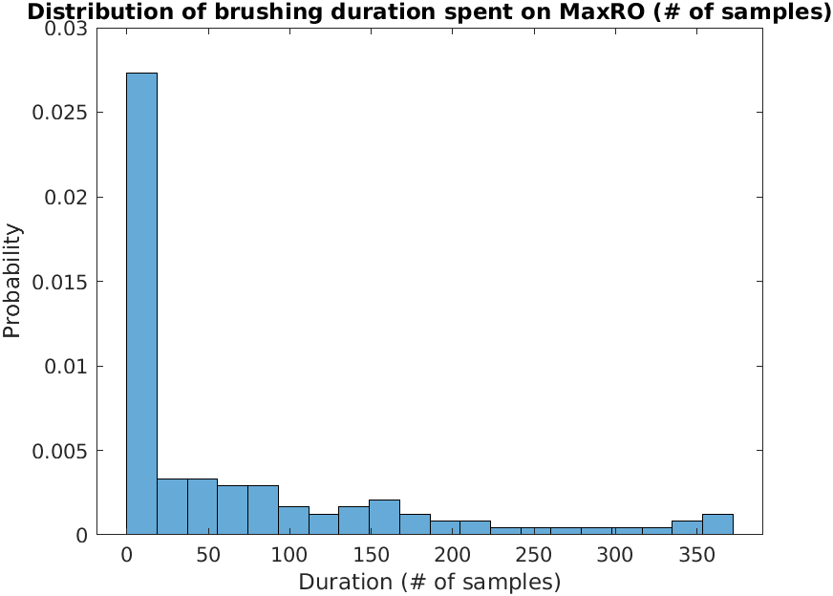

Appendix **figure 1.** Distribution of duration (# of samples) spent on MaxRO

As a result, we also fitted a zero-inflated poisson fixed-effects model defined as follows using the matlab package in [citation needed]:

$Y_{ijk} 〜 \{ 0 with probability p_{ijk} ; Pois (λ_{ijk}) with probability 1-p_{ijk}\}$ (eq. 4)

$log(𝔼(Y_{ijk})) = log(λ_{ijk}) = β_{0} + β_{ℳ}1_{\{k ∈ ℳ\}} +β_{𝒜}1_{\{k ∈ 𝒜\}} +β_{𝒢}1_{\{k ∈ 𝒢\}} +β_{𝒪}1_{\{k ∈ 𝒪\}} +β_{ℒ}1_{\{k ∈ ℒ\}}$

(eq. 5)

$logit (p_{ijk}) = -τ ln (λ_{ijk})$ (eq. 6)

The estimated coefficients are presented in Appendix table 3. All the coefficients except for $β_{𝒜}$ and $β_{𝒢}$ are still significant, confirming our results from the Poisson mixed-effects model. For comparison between brushing the dental regions on the right side versus the left or anterior side of the mouth, our tests do not produce a significant result and hence we cannot state a conclusion about that.

| Variable name | $τ$ | $β_{0}$ | $β_{ℳ}$ | $β_{𝒜}$ | $β_{𝒢}$ | $β_{ℒ}$ | $β_{𝒪}$ |
| --- | --- | --- | --- | --- | --- | --- | --- |
| Estimate | 0.206 | 5.367 | 0.119 | -0.030 | -0.020 | -0.492 | -0.571 |
| P-value | <0.001 | <0.001 | 0.003 | 0.309 | 0.340 | <0.001 | <0.001 |

In order to find the P-values of the estimated coefficients in Appendix table 3, we performed a permutation test [citation needed] in which we randomly permuted the response variable (brushing durations) for a significant amount (10000 times) to compute the distribution of each coefficient under the null hypothesis (that coefficient is zero).

## Section 2. Brushing duration with excessive pressure on each dental region

In brushing duration with excessive pressure, we observe even more zeros than in Appendix Section 1, because in a lot of regions there is no excessive pressure. Hence, we model this using the same equations as Appendix Section 1 (eq. 4, eq. 5, and eq. 6), by only changing the response variable from $Y$ to the excessive pressure $Z$. The estimated coefficients are summarized in Appendix table 4. Again, we computed the P-values using the permutation test that was described in Appendix Section 1.

| Variable name | Estimate | SE | P-value | CI |
| --- | --- | --- | --- | --- |
| $β_{0}$ | 2.920 |  | 0.9303 |  |
| $β_{ℳ}$ | -0.044 |  | 0.4995 |  |
| $β_{𝒜}$ | -0.119 |  | 0.3285 |  |
| $β_{𝒢}$ | -0.231 |  | 0.1529 |  |
| $β_{B}$ | -0.416 |  | 0.0554 |  |
| $β_{ℒ}$ | -0.376 |  | 0.0740 |  |

**Appendix table 4.** Estimated coefficients of zero-inflated fixed-effects model on brushing duration with excessive pressure on dental regions.

As can be seen from Appendix table 3, the coefficients for buccal and lingual regions are significant by considering a significance level of 0.1. This indicates that the excessive pressure on occlusal regions is more than the lingual and buccal regions. The rest of the coefficients are non-significant. To compute the standard error and the confidence intervals we bootstrapped the data on the participant level and sessions level.

## Section 3. Duration of total brushing in a brushing session

We model the total brushing duration in a brushing session $D_{ij}$ using a Poisson regression model with random effects for participants as follows:

$D_{ij} 〜 Pois (λ_{i})$ (eq. 7)

$log(𝔼(D_{ij})) = log(λ_{i}) = β_{0} + α_{i}$ (eq. 8)

$α_{i }∼N(0,{σ_{α}}^{2})$ (eq. 9)

Within subject variability: if I brush rn vs I brush at night : mean(sqrt(lambda_i)) was not good, mean(std(each participant))

In between subject variability: if I brush rn vs soemoneelse brushes rn: std(lambda)

The estimated value of $β_{0}$ was ${\hat{β}}_{0}$ = 7.982 ( $SE({\hat{β}}_{0})=$ 0.052; 95% CI: 7.88, 8.09) and the estimated random-effects are listed in Appendix table 5; the estimated standard deviation of the random effects was ${\hat{σ}}_{α}$ = 0.1876 (95% CI: 0.133, 0.291). Some of these random effects are significant (particularly for participants 5, 6, and 13) and hence suggest substantial interpersonal variations in brushing session duration.

| Variable | $α_{1}$ | $α_{2}$ | $α_{3}$ | $α_{4}$ | $α_{5}$ | $α_{6}$ | $α_{7}$ | $α_{8}$ | $α_{9}$ | $α_{10}$ | $α_{11}$ | $α_{12}$ | $α_{13}$ |
| --- | --- | --- | --- | --- | --- | --- | --- | --- | --- | --- | --- | --- | --- |
| Estimate | 0.118 | 0.029 | 0.102 | 0.004 | 0.193 | -0.157 | 0.048 | 0.090 | 0.025 | 0.088 | 0.087 | -0.043 | -0.584 |
| P-value | 0.023 | 0.577 | 0.054 | 0.943 | <0.01 | <0.01 | 0.358 | 0.088 | 0.639 | 0.097 | 0.100 | 0.411 | <0.01 |

**Appendix table 5.** Estimated random effects on total brushing duration in a brushing session